**Week-1-31/01-06/02/22**

**CN4005 STUDENT SELF EVALUATION**

**Task-1**

For each of the sections below, reflect on how you would rank your skills between 1 and 10. Indicate for each skill your evidence for that and then explain how you would improve it.

For an

explanation of these terms, please refer to the guide that will come with the form.

The first four have been created as examples for you to see.

**CN4005 Student Self-Assessment Form:**

| **Area** | **Skill level (1-5)**  **0 -2 = No evidence**  **2 - 3 = limited evidence**  **3 - 6 = Some evidence**  **7- 9 = strong evidence**  **10 = outstanding – I am better than the teachers!** | **Evidence** | | **Plans to improve** |
| --- | --- | --- | --- | --- |
| **Domain A: Knowledge and intellectual abilities:**  Relates to the knowledge & intellectual abilities needed to be able to carry out excellent research. | | | | |
| **Knowledge base** |  |  | |  |
| 1 Programming knowledge (Java) | **4** | I passed the module with 76% marks, and I did not fail any of the TCAs. But I am not fully confident. | | *I did some review study during the holiday. I will spend more time to have a clear understanding and be confident before the second year.* |
| 2. Web Design Skills (HTML/CSS) | **3** | I have completed level three but have not done anything on CSS. | | *I will commit to attending all the lectures and practical. I will read the lecture in advance and try the practice at home first.* |
| 3. Database Design skills (E-R) | **3** | I have completed level three, but I did not understand it very well. In last semester it developed a bit. Still, I am not fully confident on it. I have a negative thinking that it bis very hard. | | *I need guidance how to take-off the negativity from my mind and the way to understand easily. I have plan to put extra effort for it this summer. I will contact to my academic advisor to get right direction; I will also ask help from my friends who has good knowledge on it.* |
| 4. Maths for computing. | **5** | In first semester everything was new to me, and I got 55% on the module. I was not able to focus on the beginning of the module. I love math and enjoy it. | | *I am not scared of it.* I love math and enjoy it. *Will continue my approach to studying math.* |
| 5. Research skills (finding information) | **5** | I have developed some research skills in level three by doing assignments. I gain some knowledge when I was writing research proposal after my MA. | | I am good at reading I can decide what to read based on research topic. Reading is one of the most important skill to find information. I will put myself during the semester to developed more of the skill. |
| 6. Research citation and referencing skills. | **3** | I have done research in level three, I have good understanding of reference but not much about citation, I have only Harvard referencing for my assignment. | | *I need to focus on citation during this semester. I have register for English and Academic writing in Moodle, I need to read and watch the materials to develop the skill.* |
| 7. Computer networking skills. | **3** | I have studied Application of networks, LAN, WAN and Network Topologies in level three. | | *I found some mathematical terms in here in my module and I believe I will develop my networking skills by following lectures and completing every week task on time.* |
| **Cognitive abilities** |  |  | |  |
| 1. Analysis skills | **3** | As analytical skills are soft and critical skills. Some analytical skills include very critical thinking, and I am not very fast of it. | | I need to be more aware and find the opportunities to develop my analytical ability during my study at UEl. |
| 2.Paraphrasing skills. | **3** | I can create a restatement of the meaning of a text or passage using my own words | |  |
| 3. Critical thinking skills. | **3** | **I take time in critical thinking.** | | **I am keen to develop the ability of critical thinking.** |
| 4. evaluation skills | **4** | **I can evaluate the impact and outcomes of my own research activities** | | **I need to develop more of these skills during my study.** |
| 5.Solving problems | **5** |  | |  |
| **Creativity** |  |  | |  |
| 1. Innovative ideas | **3** |  | | **Here is the opportunity in this module to explore my innovative idea or thinking by doing practical at UEL. I am ready to take this opportunity by engaging on it.** |
| 1. Argument construction | **3** | **I have week argumental capacity. I need to build strong argumental ability.** | | **I can build up my argument construction ability by discussing with my classmates during lesson and lab session. I** |
| **Domain B: Personal effectiveness:**  The personal qualities, career & self-management skills required to take ownership for & engage in professional development. | | | | |
| **Personal Qualities** |  |  | |  |
| 1. Enthusiasm | **4** | **I have enthusiasm and can maintain strong enthusiasm for my own research** | | **I will try to be creative to be enthusiastic.** |
| 1. Perseverance | **7** | I can work towards a goal overcome obstacles and challenges to achieve the success, | | **I am willing to build more of this capacity.** |
| 1. Self-confidence | **7** | I have always positive feelings and I accept my faults. | | **The weakness I have I am willing to strengthen it.** |
| 1. Self-reflection | **7** | I practice regularly to learn and develop from my mistakes. | | **I want to keep it up to develop my weak areas.** |
| 1. Responsibility | **7** | I am capable eventually taking responsibility for my own project. | | **I want to learn more about responsibility.** |
| **Self-management** |  |  | |  |
| 1. Preparation & prioritisation | **5** | I plan and prepare my work in order to achieve my goal. | | **I will learn more about it in this module.** |
| 1. Commitment to study | **5** | I always try to fulfil commitment. | | **I am determine to study more.** |
| 1. Time management | **6** | I am good in time management. | | **I will prove by doing all my assignment on time.** |
| 1. Responsiveness to change | **5** | I can change my strategy when it is necessary. | | **I believe I will make a strong capacity of it during my study at UEL.** |
| 1. Work-life balance | ***6*** | *I can priorities to balance work and life.* | | *Still, I need to learn more to develop an awareness of it.* |
| **Professional & career development** |  |  | |  |
| 1. Career management | **6** | I can effectively promote my personal skills, characteristics and experience in CVs, applications and interviews. | | Need to progress to fulfil goals. |
| 1. Continuing professional development | **5** | I am able to develop and maintain my own records of achievements and experience. | | Always willing to learn new things |
| 1. Responsiveness to opportunities | **6** | I seek to gain broader of experience | | Always willing to learn new things |
| 1. Networking | **5** | I can build and maintain working connections with co-workers, supervisors within the institution. | | I will build up this capacity during my study at UEL. |
| **Domain C: Engagement, influence & impact :**  The knowledge, understanding & skills needed to engage with, influence & impact on the academic, social, cultural, economic & broader context. | | | | |
| **Working with others** |  |  |  | |
| 1. Collegiality | **6** | I am considerate to others at my work. | Need to develop | |
| 1. Team working | **7** | I always appreciate others contribution. | Need to develop | |
| 1. People management | **5** |  |  | |
| 1. Influence & leadership | **6** | I need to gain more of it. | I need to gain more of it. | |
| 1. Collaboration | **5** |  |  | |
| 1. Equality & diversity | **5** | I am respect full of individuals. |  | |
| 1. Communication methods | **5** | I exchange knowledge with classmate and colleagues. | I have to be more open and wider to gain it, | |
| **Domain D: Business**  The knowledge and understanding of business and what this means for you as a potential employee. | | | | |
| 1. Understanding business | **4** | Some specific business |  | |
| 1. Understanding employers | **5** | I need to have more understanding | Need to develop. | |
| Total Score: | **179** |  |  | |

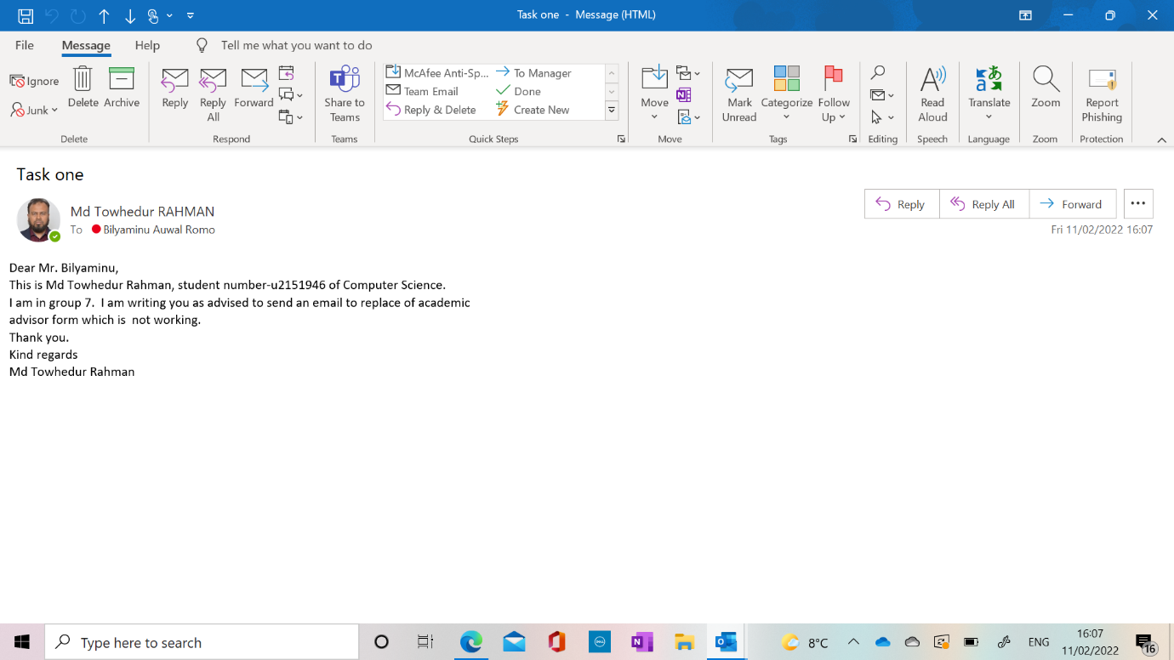

|  |  |  |
| --- | --- | --- |
| Md Towhedur Rahman **POPLAR, LONDON,**  **GRATE BRITAIN** Profile **I am willing to give total support the**  **organization that I am in, with the experience and capability that I have, in order to achieve organization’s goals and create mutual benefits.** |  | EDUCATION |
|  | **B.Sc. (Hons) in Computer Science Year one 2022**  **University of East London, UK**  **Diploma in Information Technology 2021**  **New Ham College, UK**  **Certificate in IT User Skills Level Two 2020**  **New City College, UK**  **English Functional Skills Level Two 2019**  **Tower Hamlets College, UK**  **MA Political Science 2004**  **National University, Bangladesh**  **BA Social Science 2001**  **National University, Bangladesh** |
| sKILLS aND aBILITIES  * **The ability to plan, organize and control.** * **The ability to work under pressure.** * **Highly developed communication** * **Team working and supportive at all levels**   **HOBBIES & INTERESTS**   * **Web Design** * **Programing** * **Photoshop** * **Data Organizing**  CONTACT **Phone: 0123456789**  **Email:** [**contactme@anytime.com**](mailto:contactme@anytime.com)  **REFERENCES UPON REQUEST** |  | WORK EXPERIENCE |
|  | **Customer Team Member**  **2018–2022**  **The Co-operative Group, UK**  **Counter Assistant 2015–2018**  **Village Food Court, UK**  **Facility Team Member 2012–2014**  **ISS International, Finland**    **Head Chef**  **2007–2012**  **A & H International OY, Finland**  **Senior Public Relation Officer 2006 -2007**  **Geokinetics & Cairn Energy Ltd.**  **Senior Public Relation Officer 2004 -2006**  **Grant Geophysical & Unocal Ltd**  **Public Relation Officer 2002-2004**  **PGS Onshore & Niko Resources Ltd** |
|  |  |

**Activity 1.1: Working part of a team, which one of these is key for successful delivery of outcome?**

**Drag the words into the correct boxes**

**Being Professional means:**  
  
- You maintain good

communication

 with your colleagues and tutors. This means they are always informed about what is happening in the group assignment. This also helps everyone know the progress of the work and show good time management. This it is the key to the successful delivery of the assignment and success of teamwork.  
  
The other key skills being

ethical

 teamwork member, honest and fair. As well as continuously looking to learn new skills part of

Continuous Professional Development...

.

**Activity 1.2. Identify the best practices to getting the highest grade on this module**

**Reading ahead:**

Part of your four hours a week: Read that week's lesson and if the next week's lesson is available read that. Read the slides, read the assignment, and even start Practice

**Practice:**

Practice makes perfect. And also, only by practicing and taking your time to do it, you can improve your skills. working early on an assignment.

**Formative Feedback:**

Always take advantage of formative feedback opportunity by submitting your work to get feedback on your work. On average, students who submit the work for formative feedback get 20% higher grades than those who do not.

**Deadlines:**

Never leave it to the last minute. Set your own deadline two days early and rest. Allow yourself to review it. By reviewing it you can fix, improve and maximise your grade.

**Week-2-07/02-13/02/22:**

**Activity-2.1:**

**Who do you contact if you have any questions about your assignment?**

The lab tutor

**Who do you contact if you have any questions about how to organise groups?**

The lab tutor

**Who do you contact if you have any questions about your grades?**

The lab tutor

**Who do you contact if you have any questions about something not clear on the slides?**

The lab tutor

**Who do you contact if you have spotted a mistake on a lecture slides?**

The module leader (Fadi)

**Activity 2.2. Define the following technologies:**

**Drag the words into the correct boxes**

Wearables

 ……Fully equipped computer that you wear as a piece of clothing or attached to a piece of clothing.

Implants

 ……. Technology-enabled microchip fitted into the human body.

Biometric

 ……..Using a person's physical characteristics to identify a person.

Virtual Reality

 …….. A computer visual simulation of the world into 3D using a headset.

Cave

 ……. A special 3-D virtual reality room that can display images of other people and objects located in other location.

Holographic

 …….. Devices that create, capture, and/or display images in true three-dimensional form.

Speech recognition

 …….. A system that captures what you said and converts them to digital sentences and words.

**Activity 2.3. Define the following technologies:**

**Drag the words into the correct boxes**

RFID

 Radio Frequency Identification used to identify a person.

360 Camera

 A camera that allows taking a fully rounded image. Used for Virtual Reality images are recordings.

Barcodes

 A system that optically read visual code and transmit this to a computer as numbers or text.

NFC

 It is way we pay contactless by means of near field communication.

**Activity 2.4. Define the following technologies:**

**Drag the words into the correct boxes**

Cloud computing

 A technology model that allows users to rent software, hardware, and processing online.

Quantum Computing

 A technology model that uses non-traditional encoding of data and commands, beyond zeros and ones.

Example of Cloud computing:

Using Dropbox or OneDrive to store your work in online

Example of Quantum Computing:

Using chemical signals to store and process data.

**Activity 2.5:**

**Reflect on the use of A.I. and Quantum computing with Robotics.**

**In no more than 250 words, reflect on the use of A.I and Quantum computing with Robotics.**

**Answer:**

**Artificial intelligence:**

Artificial intelligence (AI) is an area of computer science that develops machines that can solve problems and learn in the same way that people do. Machine learning and reinforcement learning are two of the most cutting-edge AIs used.

**Quantum Computing:**

A quantum computer is a type of computer that uses quantum mechanics so that it can perform certain kinds of computation more efficiently than a regular computer can.

**Robotics:**

Robotics is a discipline of engineering/technology concerned with the design and operation of robots. Robots are programmable robots that can perform tasks autonomously or semi-autonomously. Robots are capable of movement and employ sensors to interact with the physical world, but they must be programmed to complete a task.

Artificial Intelligence and Quantum Computing both can integrate with a variety of processes and increase their efficiency and value.

**Use of Artificial Intelligence in Robotics:**

Artificial intelligence is used at some level in nearly every business, from finance to manufacturing, healthcare to consumer goods, and so on. Many of us utilize artificial intelligence daily, such as Google's search algorithm and Facebook's recommendation engine.

But now the scenarios are different, AI is getting integrated into robots to develop the advanced level of robotics that can perform multiple tasks and learn new things with a better perception of the environment.

**Application of Quantum Computing in Robotics:**

While everyone is still digesting the fact that robots with the integration of AI can be intelligent, quantum computing has also approached robotics to discover some new nuances.

However, across the robotics field, the following are the significant applications of quantum computing.

**Sense: Perception, Vision, and Sensor Data Processing**

**Think: Traditional Artificial Intelligence in Robotics**

**Act: Kinematics and Dynamics**

**Observe: Diagnosis and Data Mining**

**Week-3: 14/02-20/02/22**

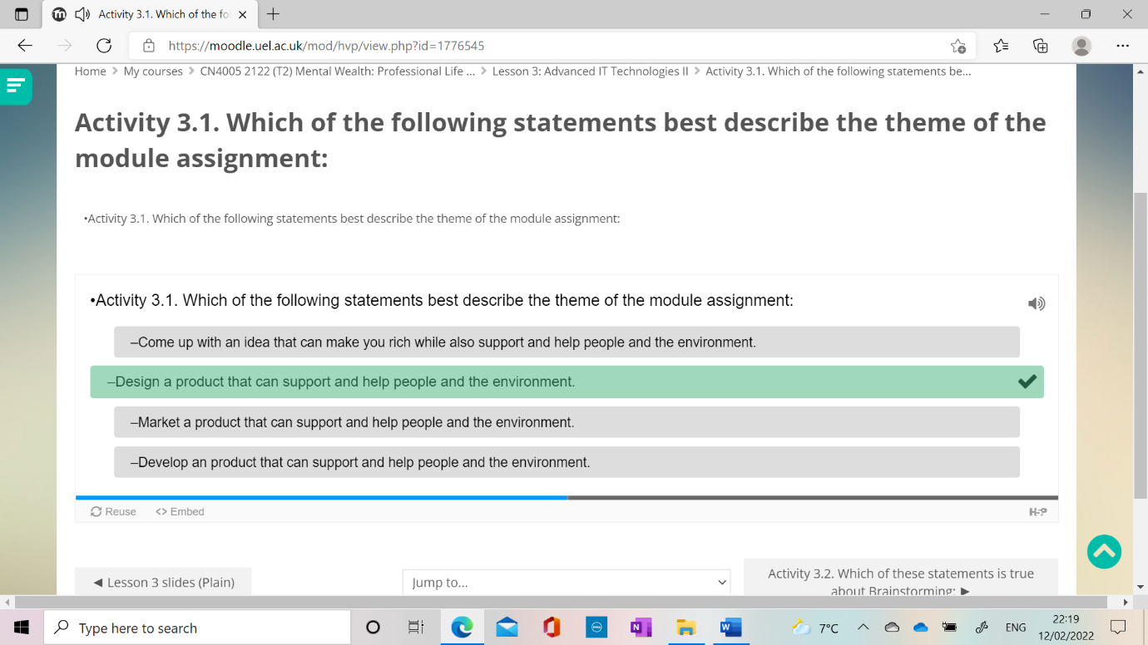

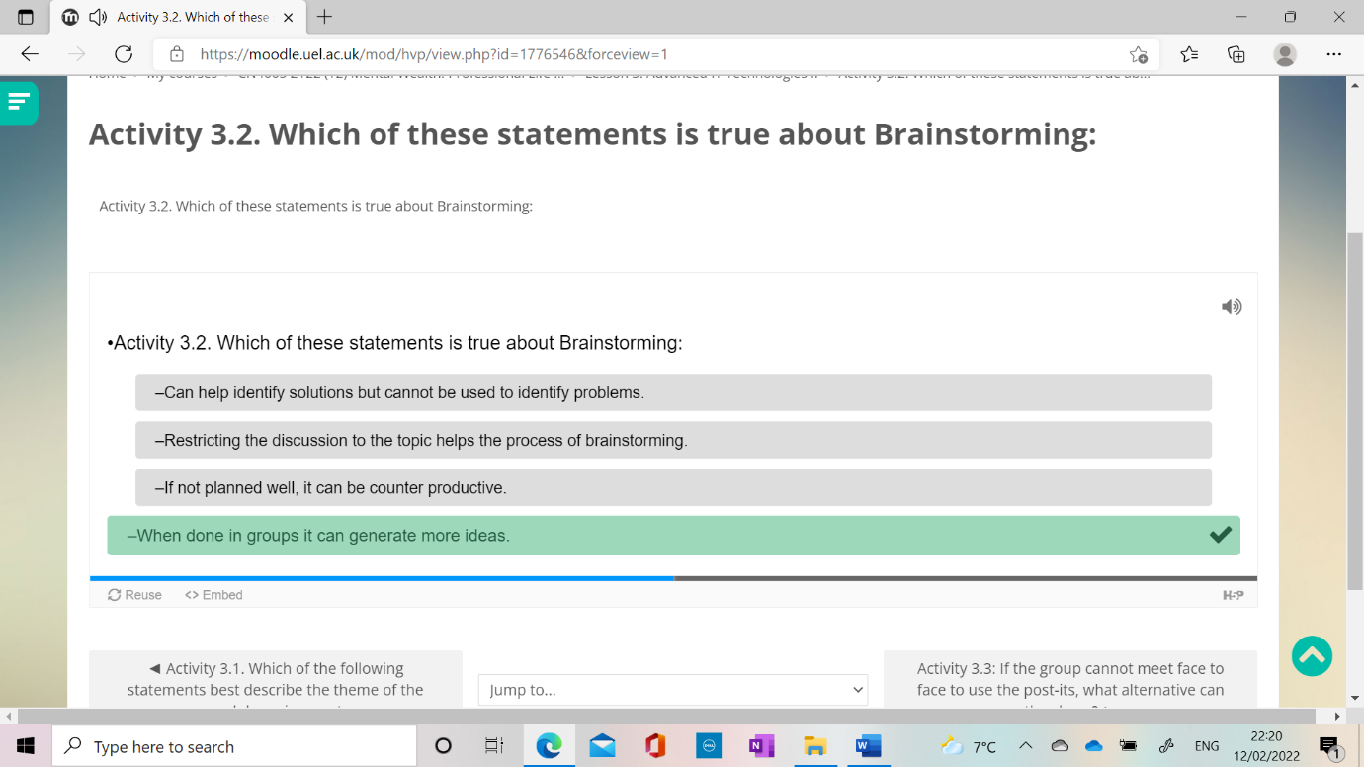

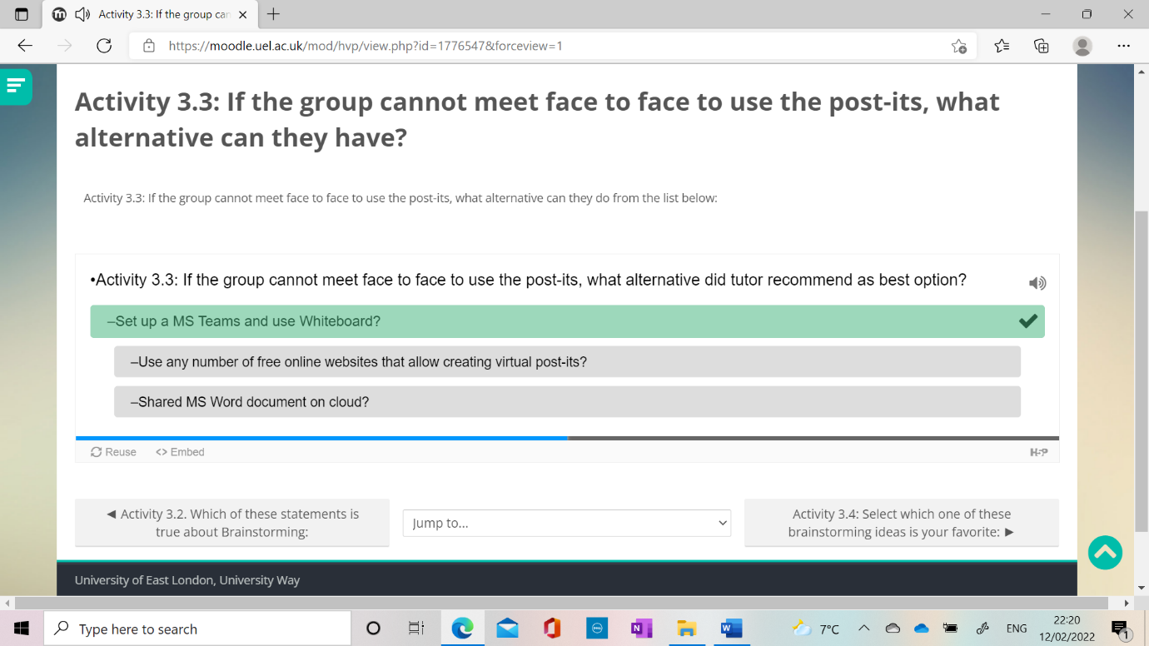

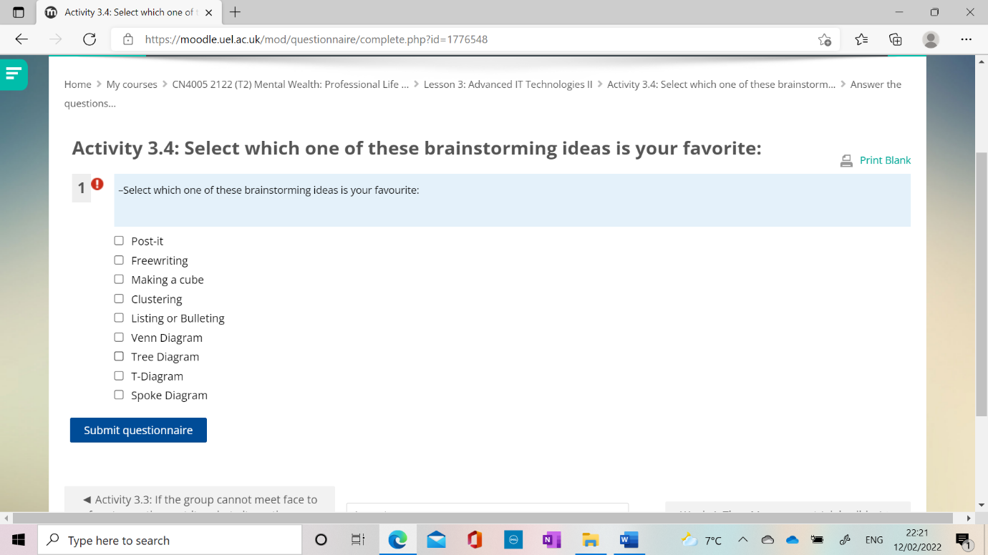

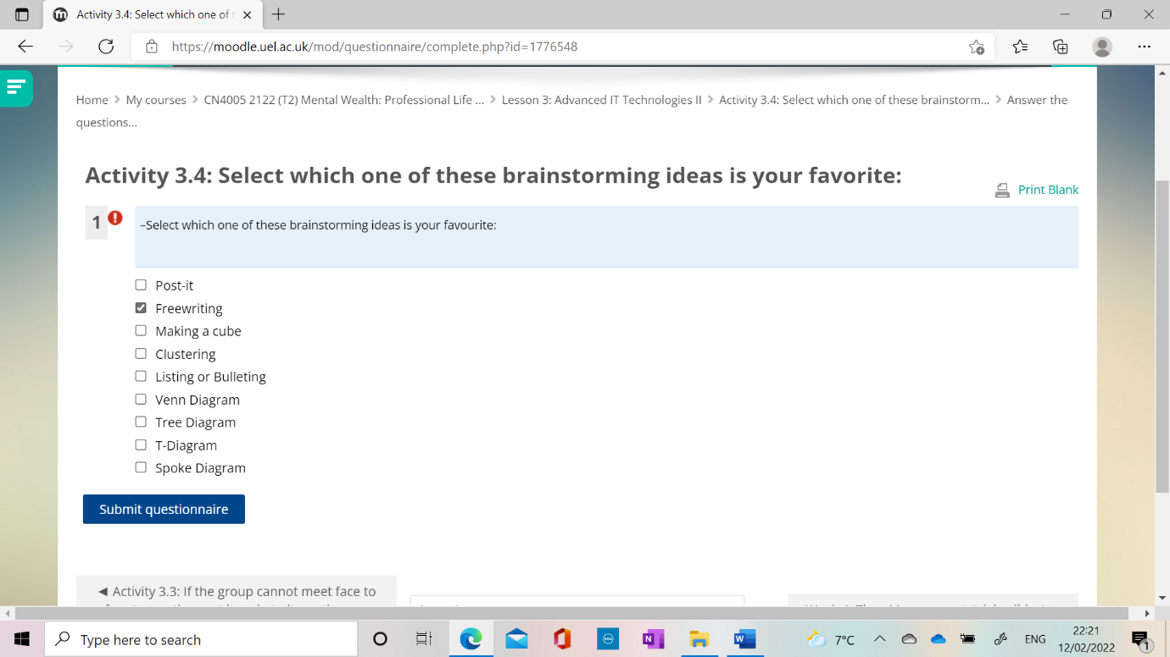

**Week-4-21/Feb-27/Feb/22**

Task 2:

Individual Time Management Plan.

Due week 4, L.O. 1 & 5. 10%

(Individual) Students to create a comprehensive time management plan based on GTD. Students are allowed to use a different approach, provided it is an academically published approach, and they provide a citation of their source. The key aspect of this assessment is that the student has demonstrated good forward planning that covers academic tasks and deadlines, personal development deadlines, and day-to-day deadlines.

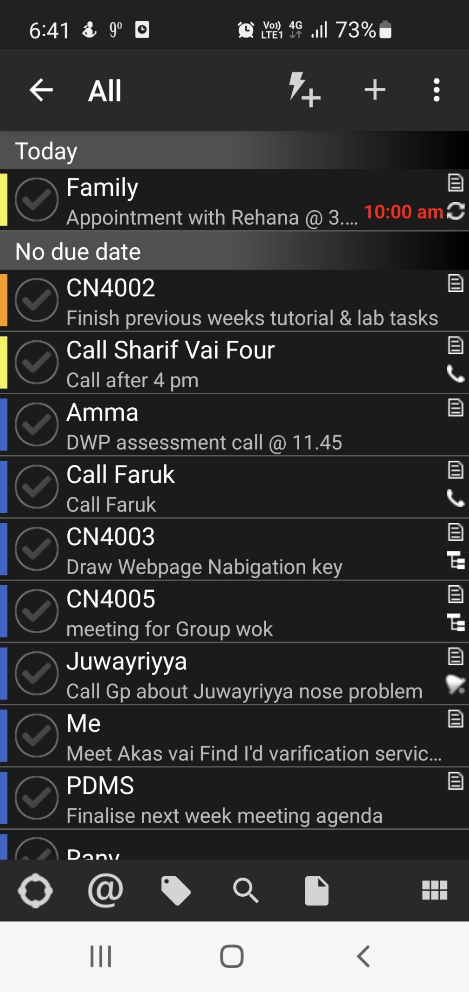

**Time Management Plan:**

**Work:**

|  |  |  |  |
| --- | --- | --- | --- |
|  |  |  |  |
|  |  |  |  |
|  |  |  |  |
|  |  |  |  |

**Family:**

|  |  |  |  |
| --- | --- | --- | --- |
|  |  |  |  |
|  |  |  |  |
|  |  |  |  |
|  |  |  |  |

**Activity 4.1. Complete the 30 mins activity of reflecting on the following questions:**

* Take the next 10 mins to write down tasks that you have to complete urgently.

|  |  |  |  |
| --- | --- | --- | --- |
| Module | Week | Task No | Due Date |
| CN4002 | Week-2 | Tutorial Question  10-15 Need answer | Week-2 |
| CN4002 | Week-3 | Tutorial question  1 need to complete | Week-3 |
| CN4002 | Week-3 | Lab practical questions 2-6 need to complete | Week-3 |
|  |  |  |  |
| CN4003 | Week-4 | Need to go through the lecture slides again to complete the lab task | Week4 |
| CN4005 | Week-4 | Target to finish on time | Week-4 |

* Take another 10 mins to add tasks you think are important but not urgent.

|  |  |  |  |
| --- | --- | --- | --- |
| Module | Week | Task No | Due Date |
| CN 4003 | Week-3 | Need to write the week activity in my word folder | Week-3- overdue |
| CN4005 | Week-4 | Target to finish today | On time |
|  |  |  |  |

* Take another 10 mins to add tasks not important, not urgent, but you wish to complete if you had more time.

|  |  |  |  |
| --- | --- | --- | --- |
| Module | Week | Task No | Due Date |
| CN4002 | Previous weeks | Lecture slides and videos to revise | Whenever have time |
| CN4003 | Previous and coming weeks | Work on finalizing the assignment web page | In advance |
| CN4005 | Previous and coming weeks | Find time to work in advance rest of the task after 2 | In advance |

**Activity 4.2. Rank your stress levels in the order of stressful:**

Drag the words into the correct boxes

Getting stuck in a car traffic jam when you have an important interview to attend very soon.

Stressful

Getting stuck on a plane when you have an important interview to attend after you land, but the plane is running late.

More stressful

Getting to the interview on time but failing it because you did not answer the questions correctly?

Least Stressful

Activity 4.3: Doing the 2-minute rule to finish tasks that need little time is important for the following key reason (Tick as many relevant):

* –Help your mind focus on the bigger tasks later.

Correct answer.

* Can be used for essay writing it you think it will take less than 2 mins
* –Means you never have to waste time thinking about them.

Correct answer.

* –Cannot be used to answer emails as emails take more than 2 mins.
* –You achieve faster turn over of task.

**Activity 4.4. Organize the GTD steps in the correct order:**

Drag the words into the correct boxes

1.

Collect

2.

Process

3.

Organize

4.

Review

5.

Do

**Activity 4.5:**

**Week-5**

**21/2/22-27/2/22**

**Activity 5.1. You have all worked in groups in the past, working with friends at school on an assignment or project. Indicate the most common reason why the team did not perform to its full capacity.**

My answer:

Poor communication: Not discussing changes or progress with the team.

Activity 5.2. How long did the tutor suggest to wait before raising the alarm that a group member is not participating? (Select as many)

* –When they fail to respond to three contacts and you have waited a week.

Correct answer.

* –Also, you can make your own agreement, but it has to be in writing.

Correct answer.

* –You meet as a group and agree to suspect the member for failing to participate.

Correct answer.

* –Two days
* –After they miss three meetings without contact.

Activity 5.3. What makes a great team? (Tick as many relevant items):

* –Being positive and constructive in your work.

Correct answer.

* –Having an agreement from the start with objectives, protocols, including actions in case of slacking.
* –Have a backup plan if there are problems.
* –Having a clear team structure.

Correct answer.

* –To be organised and prepared

Activity 5.4. Reflect on the video you just saw on “promoting Yammer”, which of the characteristics of individuals did you see:

* –Faith

Correct answer.

This is a tricky one as some of the names indicated different faiths, but that was not very obvious.

* –Gender (Females in different managerial roles)

Correct answer.

* –Age (Employees of all ages)

Correct answer.

* –Sexual Orientation (LGBTQ Rainbow)

Correct answer.

* –Race (Diverse and covering different managerial roles)

Correct answer.

* –Pregnancy (parenting)

There was no suggestion that the working environment accomodated parents or families. Many organisations have child care facilities on site to accomodate that.

* –Disability

Week-6

Activity 6.1. What is the problem you see in the first part?

* Body language – hands and legs

Correct answer.

* Using too much PowerPoint animation
* Eye contact - and not looking straight at the audience.

Correct answer.

* Trying to act as ‘too clever’
* Lack of images

Activity 6.2. What is the problem you see in the second part?

* Body language – hands and legs
* Lack of images

Correct answer.

* Monotonous (Boring) and like talking to myself

Correct answer.

* Trying to act as ‘too clever’
* Eye contact - and not looking straight at the audience.

Activity 6.3. What is the problem you see in the third part?

* Body language – hands and legs
* Presenter did not prepare well.

Correct answer.

* Monotonous (Boring) and like talking to myself
* Lack of images
* Reading from the slide with large text

Activity 6.4. What is the problem you see in the four part?

* Not turning out appropriate for the session
* Reading from paper and hiding behind paper (or other things)

Correct answer.

* Trying to act as ‘too clever’
* Using too much PowerPoint animation
* Presenter did not prepare well.
* Reading from the slide with large text

Activity 6.5. What is the problem you see in the fifth part?

* Using too much PowerPoint animation
* Trying to act as ‘too clever’

Correct answer.

* Not turning out appropriate for the session
* Reading from the slide with large text
* Presenter did not prepare well.

Activity 6.6. What is the problem you see in the sixth part?

* Not turning out appropriate for the session
* Reading from the slide with large text
* Not turning up having rehearsed well.

Correct answer.

* Using too much PowerPoint animation

Activity 6.7. What is the problem you see in the seventh part?

* Not turning out appropriate for the session
* Using too much PowerPoint animation

Correct answer.

* Not turning up having rehearsed well.
* Reading from the slide with large text

Activity 6.8. What is the problem you see in the eight part?

* Reading from the slide with large text
* Not turning out appropriate for the session

Correct answer.

* Not turning up having rehearsed well.
* Using too much PowerPoint animation

Week-07

Student Self-Evaluation for presentation:

Student ID:

|  |  |  |
| --- | --- | --- |
| **Criteria: explanation** | **Allocation** | **Grade** |
| **PowerPoint: The quality and content of the PowerPoint presentation.**   * Presentation Structure * Presentation use of bullet points * Use (but not overuse) of animation * Good use of images and graphics * Color theme matches | 10pts |  |
| **Preparation: Did the group present in a professional manner?**   * Eye contact with audience * Variable voice while speaking * Rehearsed (not reading from the slides). * Transitioning between groups. * Explanation of difficult terms. * Dressed for the occasion. * The presentation content is presented in an interesting way. | 10pts |  |

**Explain your evaluation of your presentation:**

**Explain what you will do to improve key challenges you had in the presentation:**

Activity 7.1. Organize the following topics in the correct order of a presentation:  
1.

Title [Slide]

2.

Table of Content ...

3.

<<Content&g...

4.

References [Slide]

5.

Q&A [Slides

**Activity 9.1. Think of the process of booking a flight, hotel, or cinema. They all follow similar steps. Organise these in the correct order:**

Drag the words into the correct boxes

1.

Search for what y...

2.

Find what you want.

3.

Login or register.

4.

Enter the payment...

5.

Confirm everythin...

6.

Process the payment.

7.

Booking confirmed...

Activity 9.2. Select the statements that are true below:

-Prototyping does not help customers decide what they want.

-Paper prototyping is expensive to create.

-Prototyping allows better visualisation of product.

Correct answer.

-Paper prototyping is quick and easy way to visualise

Activity: 10.1: How does your body react to stress? Select as many as you spot:

 Blood pressure rises.  
 Breathing becomes more rapid.  
 Digestive system slows down.  
 Overeat  
 Undereat  
 Heart rate (pulse) rises.  
 Immune system goes down.  
 Muscles become tense.  
 Sleeping can be more of a problem.  
 None of the above

**Activity 10.2: From the lesson today, which one of these points do you take home as a way to reduce stress (select as many as you feel useful):**

Top of Form

•Activity 10.2: From the lesson today, which one of these points do you take home as a way to reduce stress (select as many as you feel useful):

 Learning when to refuel (having breaks)  
 Identifying sources of problems.  
 Learning how to relax  
 Doing positive activities that makes you feel good.  
 Be active and do sports  
 Connect with family and friends, share concerns  
 Writing what is on your mind  
 None of the above

Activity 11.1: What is the one thing that is common between all those ideas that got so much funding?

* –Cheap ideas
* –Innovative ideas

Correct answer.

* –All of the above.
* –Ideas that someone else had come up with before.
* –New ideas

Activity 11.2. If you set up a consultancy company and link to a website that allows project get sent to you, this is what we call:

* –Free economy
* –Online economy
* –Gig economy

Correct answer.

* –Capitalist economy

Bottom of Form